Exhibit A:
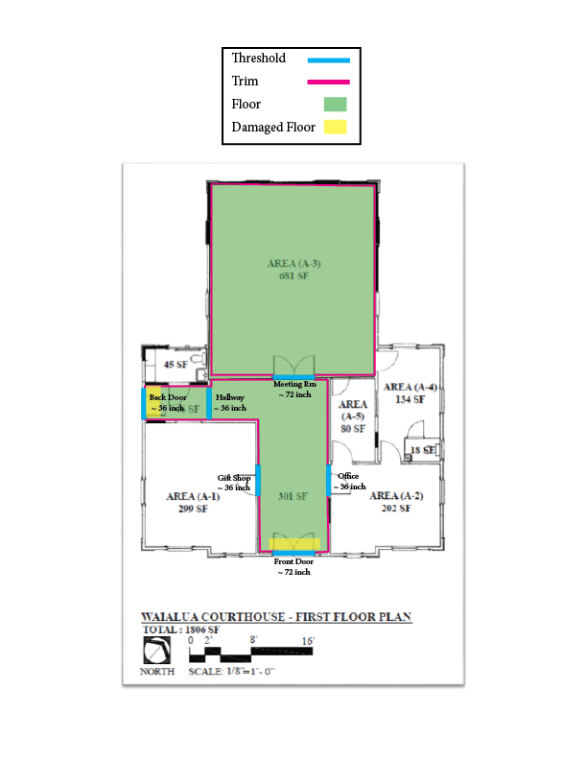

Exhibit B: Images of Floor, Thresholds, and Trim
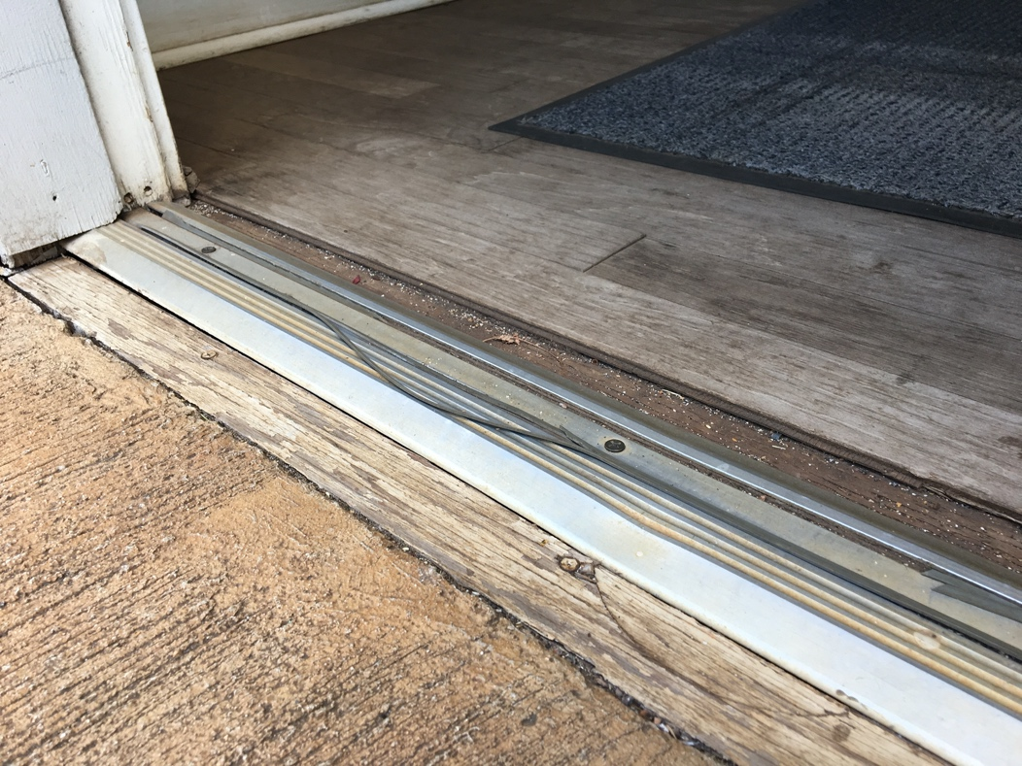
Figure 1. Damaged planks located at the backdoor entrance.

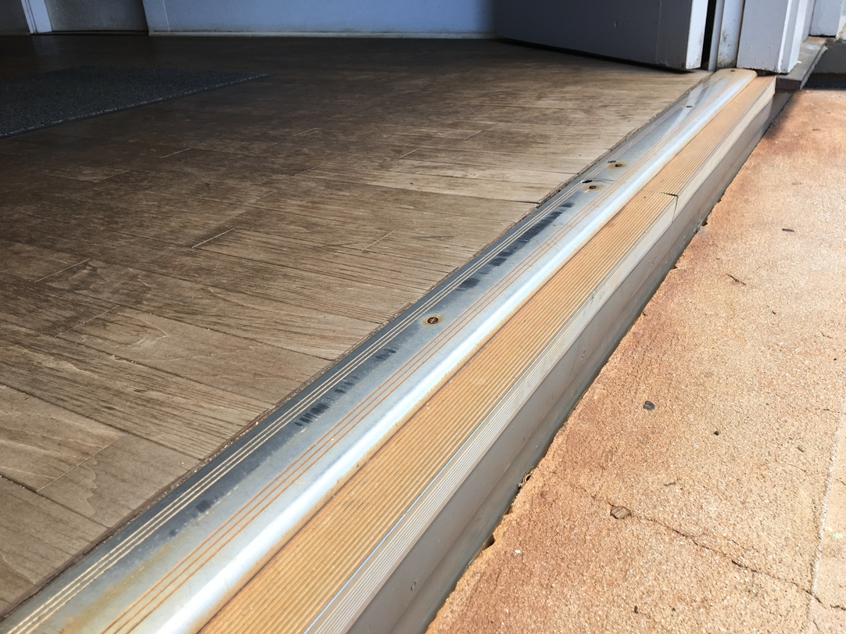
Figure 2. Front door entrance has some water damaged planks.

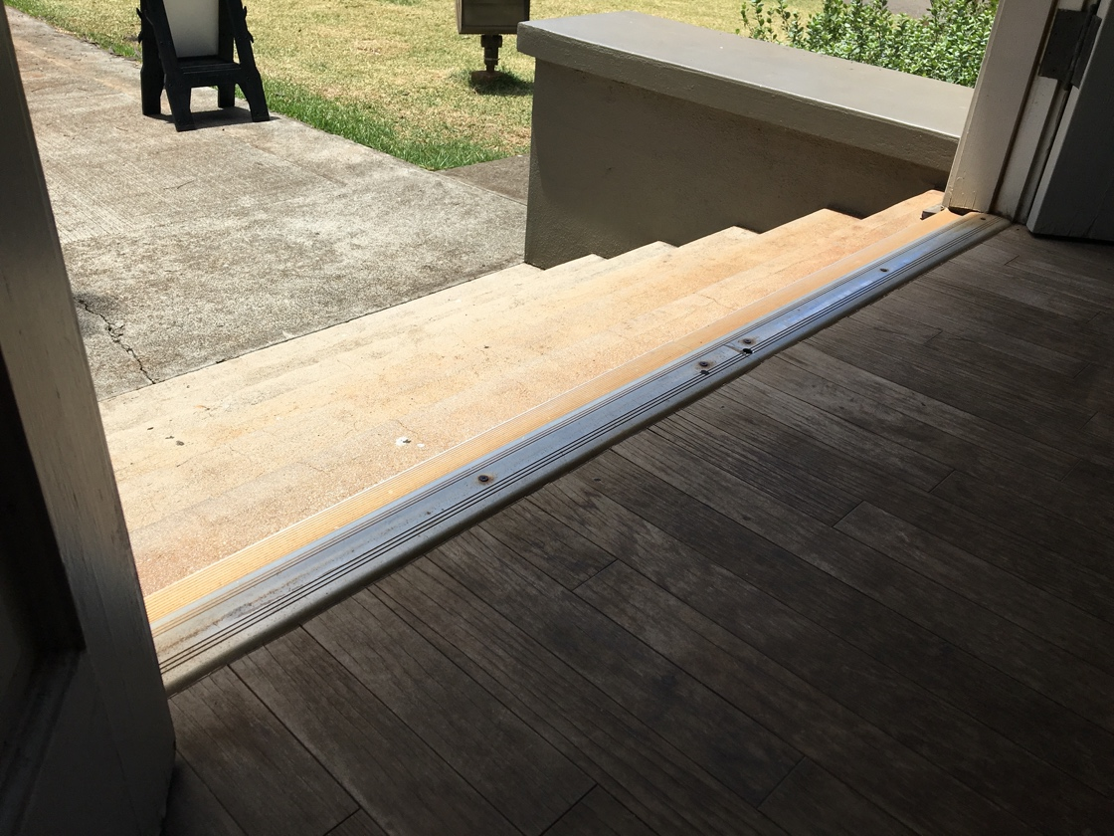
Figure 3. Front door entrance.

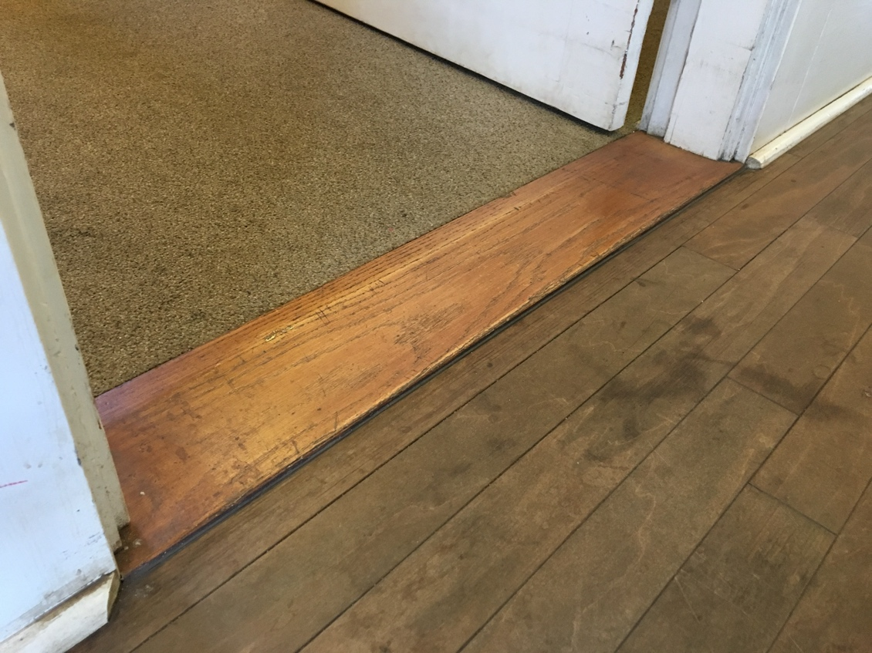
Figure 4. Gift shop threshold.
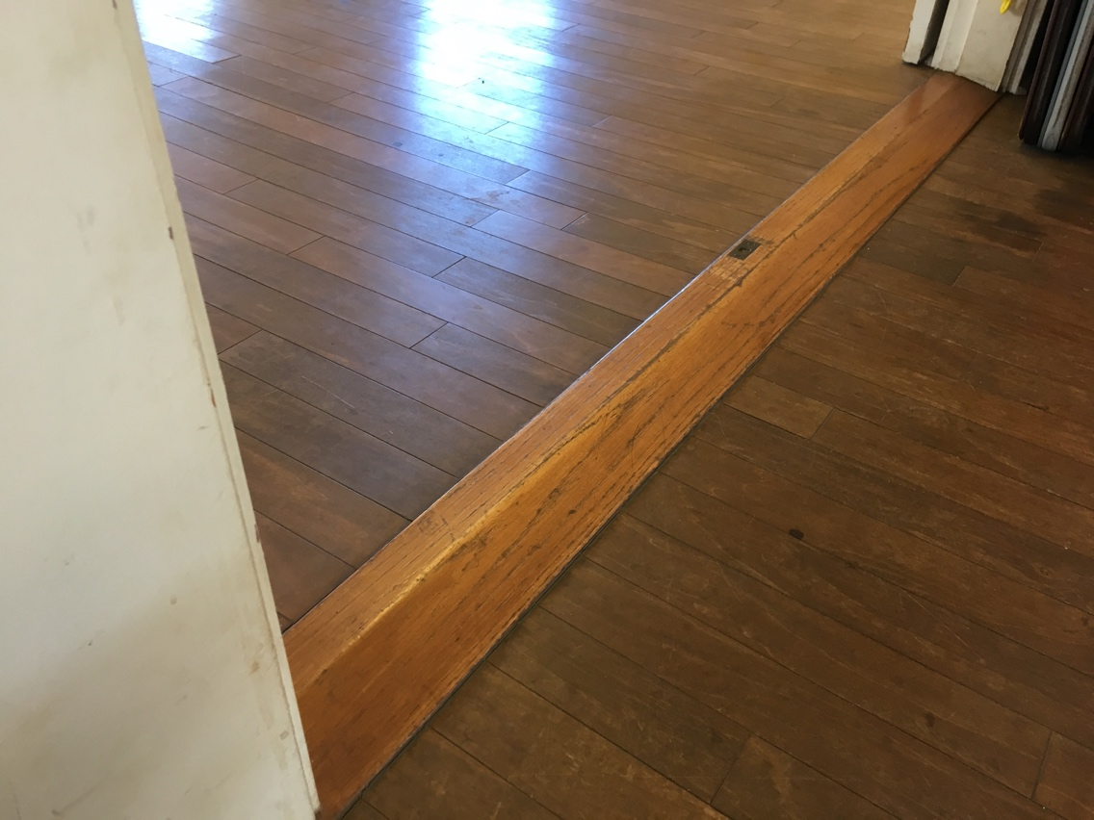
Figure 5. Meeting room threshold.

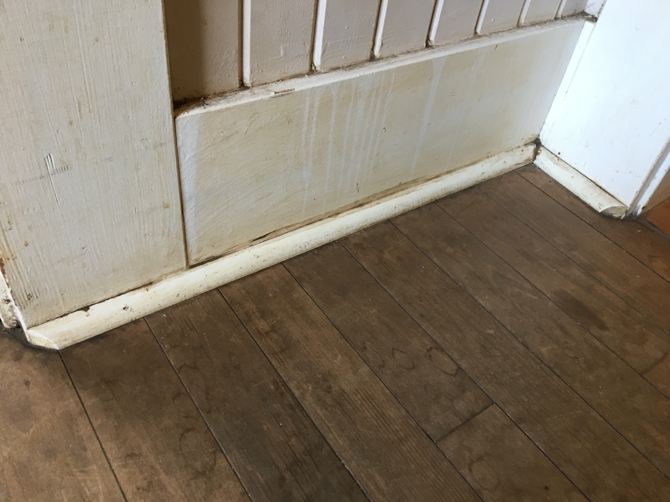
Figure 6. Trim found in the building.

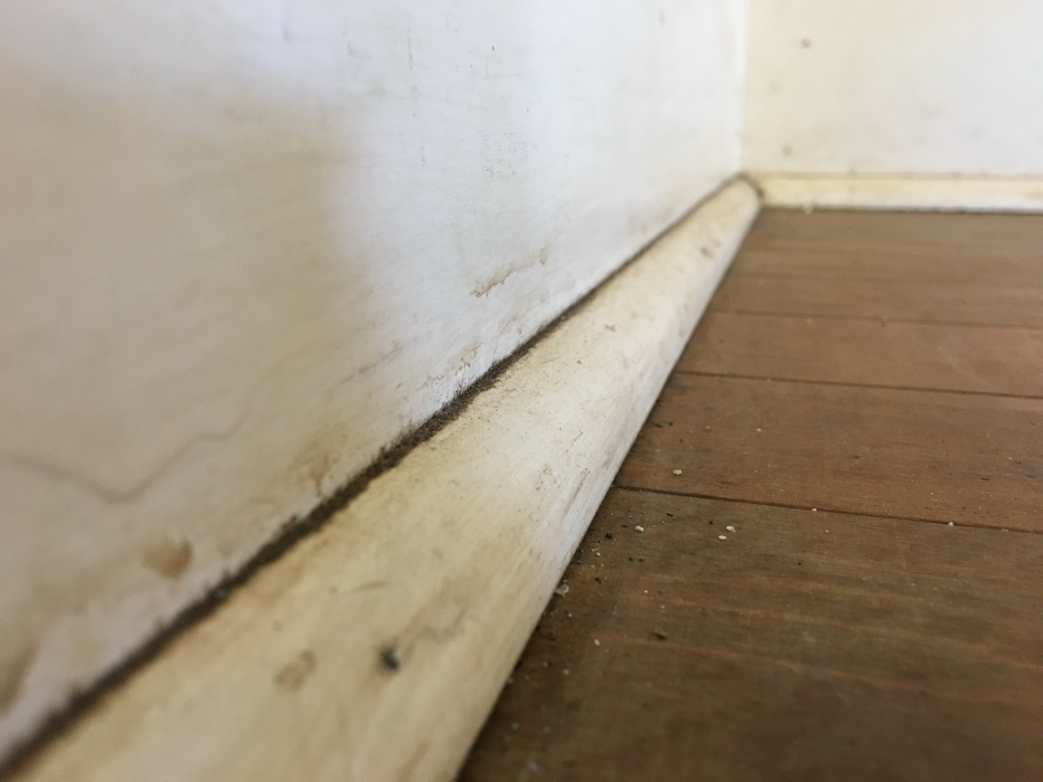
Figure 7. Close up of trim.
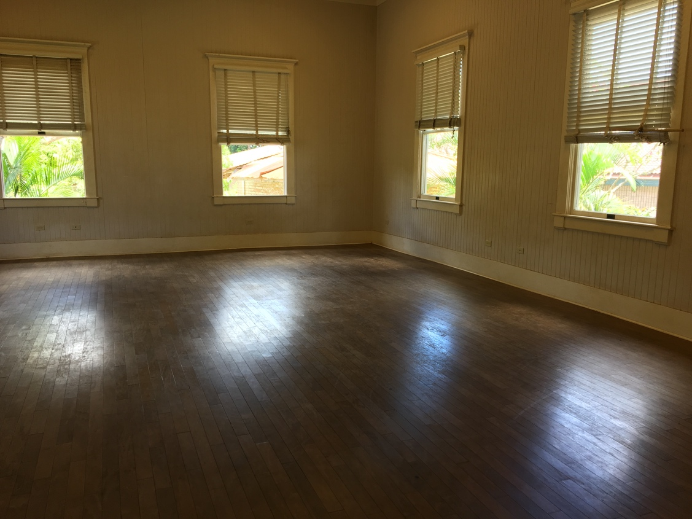
Figure 8. Meeting room

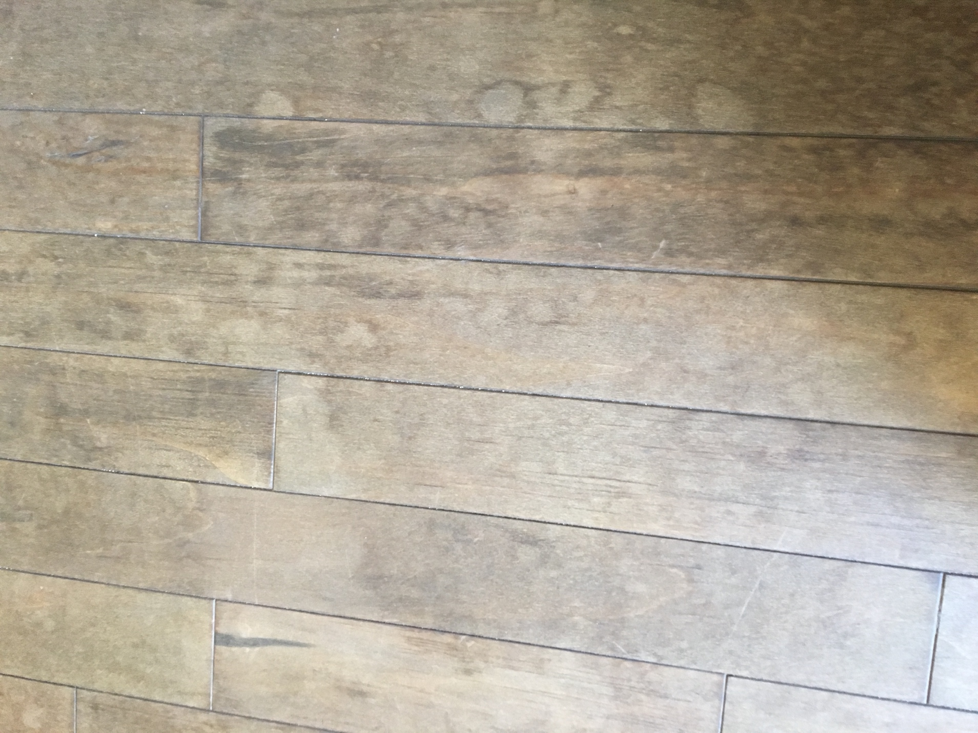
Figure 9. Picture of the condition of the floor.

